**Harbor Permit Manager (HPM)**

**By PeopleGIS**

HPM is the latest online data management service created by PeopleGIS. HPM provides all of the data management and mapping tools a Harbormaster needs to maintain mooring and slip permits and waiting lists.

HPM is built for municipal staff who manage the permitting of boat moorings and slips. Three Cape Cod communities shared their permit processes with PeopleGIS, and we created a set of web forms that enables their work flow to be managed online.

Our goals for this project were to organize this type of information at a very high level while ensuring the tools were simple and easy to use. We wanted staff to have access to the data anywhere they had access to the Internet, including on the water in their harbors as they see possible issues requiring clarification and/or action.

We also wanted to cut down of the envelop stuffing that occurred every fall as permits were up for renewal, to eliminate the effort required to publish waiting lists online for public review, and to cut the costs associated with communicating with permit holders and wait listees.

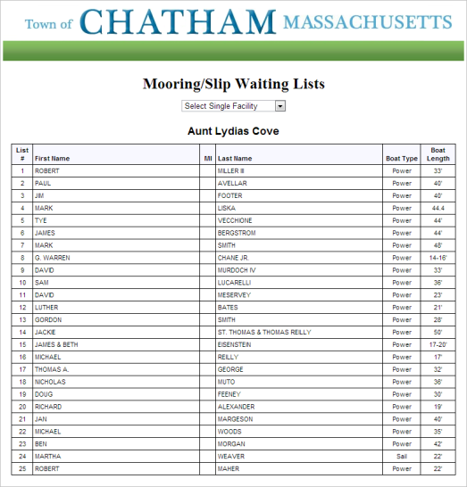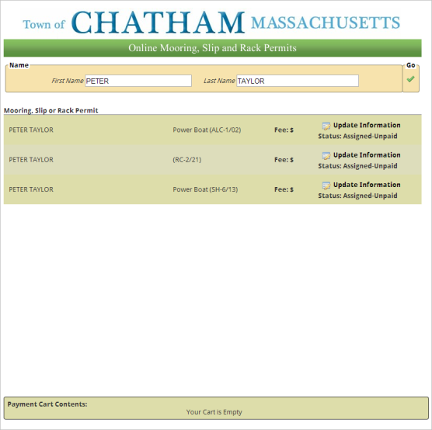There are three primary components to HPM, including the Public Wait List, and the Public Update/Payment Website, and the Staff Control Panel. Each of these components is described below.

**Public Wait List**

The Public Wait List is a live, up-to-date website showing all members of your Harbor Wait List. All changes made by the staff as Wait Listees are assigned to mooring or slip spaces are automatically show in the Public Wait List webpage so no effort is required to keep this page updated.

**Public Update/Payment Website**

The Public Update/Payment Website serves two purposes:

* Permitees and Wait Listees can access their records and update their personal or boat information
* Permitees and Wait Listees can pay for their records as part of the renewal process.

This is the webpage that Permitees and Wait Listees are directed to by email each Fall to participate in the renewal process. Emails are automatically generated by the software for all Permitees and Wait Listees that have provided emails in their applications. This approach is expected to eventually eliminate 90% of the printing and mailing needs associated with traditional renewal processes involving paper forms and the US Mail.

**Staff Control Panel**

The Staff Control Panel includes all of the tools necessary to manage permits, wait lists, payments, mapping, and more. This feature is a webpage including the following tabs:

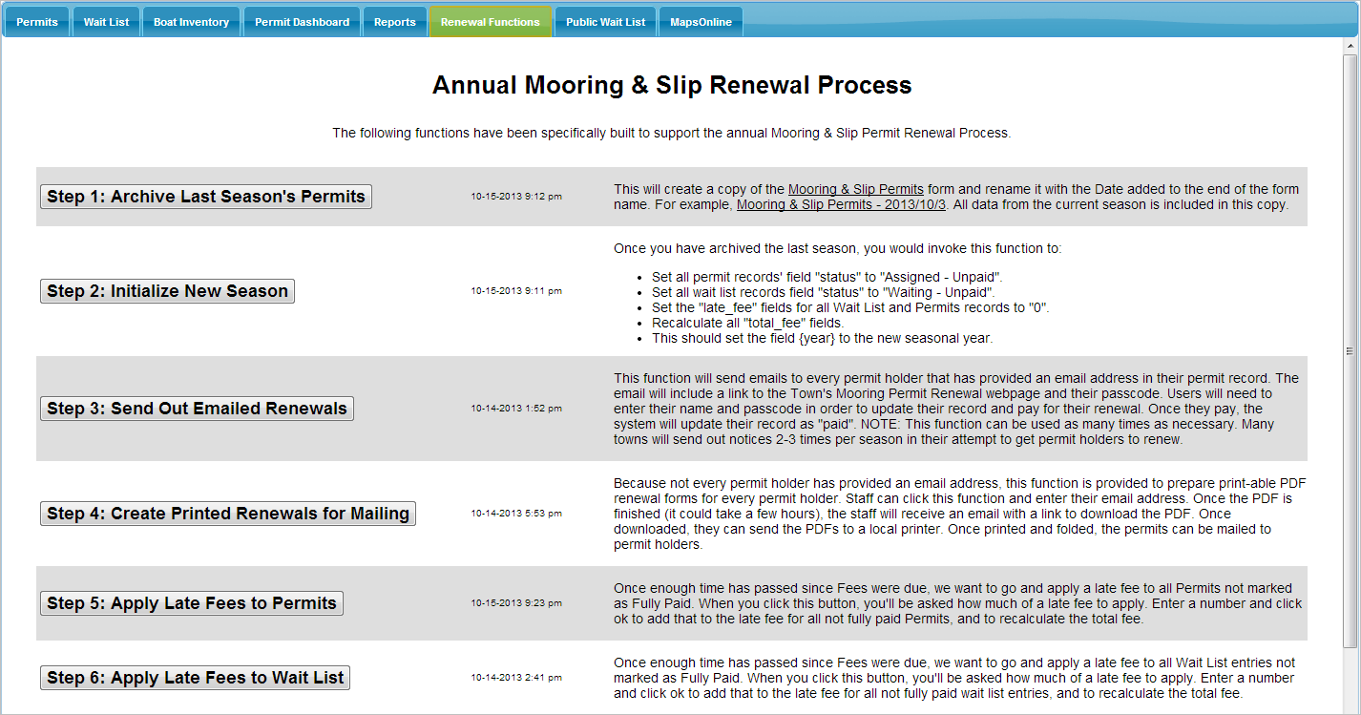

* Permits: Mooring & Slip Permits are managed in this web form. All owner information, boat information, notes, inspections, and payments are managed on this tab. New records can be added by staff for new mooring locations and slips that are added. However, the more common occurrence is to re-assign a permit record to one of the top members of the Wait List.
* Wait List: Mooring & Slip Wait Lists are managed in this web form. All Wait Listee information, boat information, notes, and payments are managed on this tab. New records can be added by staff.
* Boat Inventory: All boats entered into the Mooring & Slip Permits form are copied to this form. This allows the staff to change a Permitee’s boat at any point in time, including mid-season. This also provides a history of boats that have been moored at each mooring space over time.
* Permit Dashboard: This tab shows all Permit records by payment status. This is most useful at or near the end of the permit renewal process when your staff needs to work with those mooring permits that have been forfeited. Staff can use this dashboard to show all forfeited permits. This allows them to access these records one at a time and re-assign them to Wait Listees.
* Reports: This tab provides controls to generate various reports.
* Renewal Functions: This tab provides several macros that walk your staff through the permit renewal process. Steps include data archiving, initialization of fees, email forwarding, and preparation of mailing materials (for those Permitees and Wait Listees that have not provided emails).
* Public Wait List: This tab presents the Public Wait List so the staff can access this page without having to leave the Staff Control Panel.
* Public Update/Payment: This tab presents the Public Update/Payment website so the staff can access this page without having to leave the Staff Control Panel.
* MapsOnline: This tab presents the Harbormaster MapsOnline site which shows the known locations of mooring and slip spaces.

**Mooring & Slip Manager System Features:**

* Manages Mooring, Slip and Rack Spaces
* Manages Waiting Lists
* Handles Multiple Mooring, Slip, and Rack Facility Locations
* Staff can add unlimited notes to permit and wait list records
* Maps all Moorings, Slips and Rack Spaces
* Can be accessed on desktop computers and tablets (Android & iPads)
* Generates Reports
  + - Waiting Lists
    - Available Moorings, Slips & Racks
    - Unpaid Moorings, Slips & Racks
* Generates live HTML Waiting Lists (for inclusion in your town website)
  + - Automatically Updated
    - No Editing Required!
* Re-Assign Moorings, Slips and Racks to members of the Waiting List
* Automated Email notifications to permit holders
* Automated Email notifications to wait listees
* Ability to update/replace boat information mid-season
* Custom fee calculations
* Integrated Senior Discounting (if applicable)
* Automated check for delinquent payments (if required)
* Ability to document/manage Third Parties (temporary or seasonal)
* Maintains Payment Histories
  + Cash, Check, Online Payments
* Late Payments capabilities
* Online Payments Integration
* Ability to map mooring and slip locations by GPS
  + Longitude & Latitude Decimal Degrees
  + Longitude & Latitude Decimal Minutes
  + State Plane Coordinates
* Communicate with patrons for annual renewals
  + By email
  + By US Mail (generates/prints mail-able renewal forms)
* Archives each year’s database for future reference
* Resets permits for each season’s renewal process

**Mooring & Slip Manager**

**Work Flow Summaries**

**Annual (Fall) Setup for Permit Renewals**

When the Town is ready to prepare for permit renewals (usually in the fall), visit the Functions Tab on your HPM Control Panel and click “Archive Last Years Permit Records”. This will copy the HPM Permit database (and all current data), and name the archived version of the permit “HPM Permits – 20XX”. For example, in October 2013 a community may wish to begin the permit renewal process and click this button to create an archive of the permit database that would now be called HPM Permits – 2013. This would set this community up to begin the permit renewal process for the 2014 season.

After archiving, the system will also go into the still-active HPM Permits form and change the current year to 2014 (to prepare this database for the coming 2014 season).

All records will remain in the HPM Permits database since the assumption is made that most permit holders intend to renew. They will be given the opportunity to update their information (new address, phone numbers, email, boat, etc.) and pay for the upcoming season.

**Communicating with Permit Holders for Renewals (Mailings & Emails)**

**Tracking Renewal Progress**

At any point during the renewal process, Staff can visit the Reports Tab on the HPM Control Panel and click the “Renewal Status Short Report”. This report will provide a pie chart showing the percentage of permit holders that have renewed vs. the percentage of permit holders that have not. Clicking the “Renewal Status Long Report” will provide the same information with several additional pages listing those permit holders that have not yet renewed their permits.

**Ending Permit Renewal Process**

At some point, the Town will decide when to end the renewal process. This means that all permit holders that have not renewed their permits are going to lose them, and these permit records will be reassigned to members of the Wait List. To affect this change in the system, Staff should visit the Functions Tab on the HPM Control Panel and click the “End Renewal Process” button. Upon doing so, the system will change the status of all un-renewed permit records to “Unassigned”, thereby making them eligible for re-assignment.

At this point, staff could visit the Reports Tab of the HPM Control Panel and click the “Unassigned MSR Permits” report to generate a PDF document of available moorings.

Also, staff could visit the MSR Permits Dashboard, open the Filter accordion on the left and filter on “status” = “Unassigned”. The dashboard will not only show available moorings.

**Re-Assigning Available Moorings to Wait Listees**

Certainly, the process of re-assigning moorings to Wait Listees could be completely computerized. The system knows who is next on each list and what moorings are available. However, there remains the need for human decision-making and assessment at this critical point in the process. There are a multitude of factors to consider when deciding which Listees to offer moorings to. In addition, Wait Listees may reject the mooring being offered (see Handling Wait List Rejections). For all of these reasons, we have created HPM tools to support the human process of mooring re-assignment.

To prepare for the re-assignment process, staff should visit the Reports Tab on the HPM Control Panel to generate a Wait List Report for All Facilities. Send this PDF report to your printer. This document is setup so staff can treat it as one document, or separate the report into individual documents by facility, whichever makes the re-assignment easier.

Now that you have your paper reports in front of you, visit the MSR Permits Dashboard, open the Filter accordion on the left and filter for unassigned moorings for a particular mooring area/facility. You now have all the information you need in front of you to start the human process. We understand you will need to phone Wait Listees to ascertain their readiness, their boat, etc. In addition, you could use the MapsOnline tab to find the available mooring’s location to learn more detail about the specific location and how that might affect your selection of Wait Listee.

Once you are ready to re-assign a particular mooring (because you have determined who on the Wait List is ready and appropriate, then click on the Edit Button for that mooring in the dashboard (or visit the MSR Permit Tab and search for the mooring). Once the permit record is open, open the Re-Assignment section, and pull-down the list of Wait Listees. You should find the person you are looking for in this list. Select them and then click the Update button at the bottom of the form. This will update the permit record and prepare it for new data entry. The last permit holder’s information will be removed (don’t worry, their data is still in last year’s archive copy of the database), and most of the Wait Listee’s information will be copied from their Wait List record to the re-assigned MSR Permit record. The system will also temporarily mark the Wait Listee’s Wait List record as “Assigned”.

Staff will now need to review the re-assigned MSR Permit record with the new holder to complete all information. Their address information should be reviewed for updates, as should their email address and other contact information. Certainly, their boat information will need to be completed, along with their ground tackle, etc.

Will the system send the new person an email so they can fill out, pay, etc.?

**Handling Wait List Rejections**

Wait Listees may reject the offer of a mooring permit. Wait Listees may simply not be in a position to use the mooring at that time.

Some communities allow Wait Listees to reject an offered mooring without losing their spot on the Wait List. Other communities limit the number of rejections. Still others do not allow rejections at all.

Regardless, the Wait List form has a Rejections section that allows the Staff to track rejections. Open the Wait List form, search for the person in question, and then open the Rejections section. Click the plus button under Rejections History to open a small form to document the date and any necessary explanation/notes. Once you close the small form, you will see a link to this information added to the Wait Listee’s record.

If some number of rejections results in your community moving a Wait Listee to the bottom of the Wait List (for their respective mooring area), the Rejections section also provides tools to do so. In this case, check off the box labeled “Move this Wait Listee to the bottom of the Wait List”. The system will change the Date the Listee was added to the list to the current date, effectively moving them to the bottom of the list. You will notice an immediate change in all reports and the live HTML Wait List Page.

Now, because mistakes happen in procedures like this one, another check box has been added to this section labeled “Oops…I made a mistake. Move this Wait Listee back to their original place on the Wait List”. If necessary, staff can check this box and the Original Date will be re-instated for this Listee, effectively moving them back to their original position on the list.

**Changing a Boat Mid-Season**

It is common for a Permitee to change their boat mid-season. Because of this, we created the Boat Inventory form. This allows the software to track more than one boat for each space over time. This allows the staff to research the history of boats at a mooring space.

To change a boat mid-season, open the Permit form, search for the permit record by Owner’s Name, Boat Name, Space ID, or other attribute. Once you have the correct record, open the Boat Information section. You will find “Add a Boat” at the bottom of this section. Click the plus symbol, fill out the new boat’s information, and click Submit. The system will replace the permit record’s boat information with the new boat data.

Links to each boat record will now show below this question.

**Using the Permit Dashboard**

**What to do with System Variables**

Nothing. Leave this section alone! It is read only to most users of the forms.

**Customization/Setup Requirements Checklist**

|  |  |  |
| --- | --- | --- |
| **REQUIREMENT** | **DONE** | **NA** |
| Edit the Length questions to fit their approach to measuring boat length |  |  |
| Alter legacy permit data to ensure incoming data fields match the form fields   * Add “Wait List Pass Variable” field (ie. ${wait_id} + “ _ “ + “Waiting“ |  |  |
| Alter legacy wait list data to ensure incoming data fields match the form fields   * Add ${status} field, set all to “Waiting” if they have always removed folks from list that have been assigned. * Add “Wait List Pass Variable” field (ie. ${wait_id} + “ _ “ + ${status} * Add “Reassign Pass Variable” field (ie. ${wait_id} + " - " + ${facility} + " - " + ${fname} + " " + ${lname}) |  |  |
| Create a polygon shapefile of their facility locations, with NAME attribute |  |  |
| Create a Harbormaster MapsOnline site   * + Remove all non-pertinent layers   + Add Moorings, Slips & Rack Facilities polygon layer from form   + Add Moorings, Slips & Rack Facilities point layer from form   + Add Mooring, Slip & Rack Facilities Quick Zoom from form   + Add NOAA Charts as default tiled base map   + Remove Bing, Abutters, Property Searches   + Rename MSRF layers depending on if the town has slips and racks |  |  |
| Create HPM Permit Dashboard |  |  |
| Create Harbormaster Control Panel   * + Add HPM Permits form   + Add Waiting List form   + Add HPM Permit Dashboard   + Add Harbormaster MapsOnline site |  |  |
| Customize fee calculations   * + Adjust as necessary   + Remove Senior Discount if Town does not provide them |  |  |
| Waiting List   * + LOA…does their legacy data just have loa, or do they have pulpit, etc. Change accordingly. |  |  |
| Residency: check to see if they have discounts for seniors. If not, change the residency question in the permits and waiting list forms. Also, the options for this question will affect the hidden status of address sections, so you need to review these for proper performance. |  |  |
| Ground Tackle section – need link to each town’s online regs |  |  |
| Holding Tank – Chatham had more detail than most, and they did not track gallons of tank. May need to edit these questions a bit for other towns. |  |  |
| Put the {year} value in all loaded records for permits and wait list |  |  |
| Calculate the pass variables in the loaded wait list records |  |  |
| Place the fee payment variables in the system variables for both permits and wait lists |  |  |
| Populate Parcel IDs for existing records for both permits and wait list |  |  |
| Set the {status} for each loaded permit record to “Assigned – Paid” |  |  |
| Set the {status} for each loaded wait list record to “Waiting – Paid” |  |  |
| Update the {space} types to match what the town has to offer |  |  |
| You will want to replace ‘codes’ with actual values…they work better on the renewal receipts (people that read them do not know what the code values mean). For example, have values of “Power”, “Sail”, and “N/A” for boat type instead of P, S, and N/A. This applies to {fuel}, {boat_type}, {res_status}, and others. |  |  |
| Add “Boat Photos”, “Boat Registrations”, and “Tackle Inspections” to the Document Manager types. These are folders for the uploaded documents. |  |  |
| Setup Control Panel   |  |  |  | | --- | --- | --- | | TAB CONTENT | TAB NAME | TAB SOURCE | | Harbor Permit | Permit |  | | Harbor Wait List | Wait List |  | | Boat Inventory | Boat Inventory |  | | Permit Dashboard | Permit Dashboard |  | | Reports | Reports |  | | Fees | Fees |  | | Renewal Functions | Renewal Functions |  | | Public Wait List | Public Wait List |  | | Payment Website | Payment Website |  | | MapsOnline | MapsOnline |  | | Help | Help |  | |  |  |
| Setup Forms   |  |  | | --- | --- | | FORM NAME | ID | | Boat Inventory |  | | Ground Tackle Inspections |  | | Harbor Permit Fees |  | | Harbor Permit Notes |  | | Harbor Permit Payments |  | | Harbor Permit Rejections |  | | Harbor Permit Third Parties |  | | Harbor Permit Wait List |  | | Harbor Permits |  | |  |  |
| Move form ownership to client |  |  |